Zones
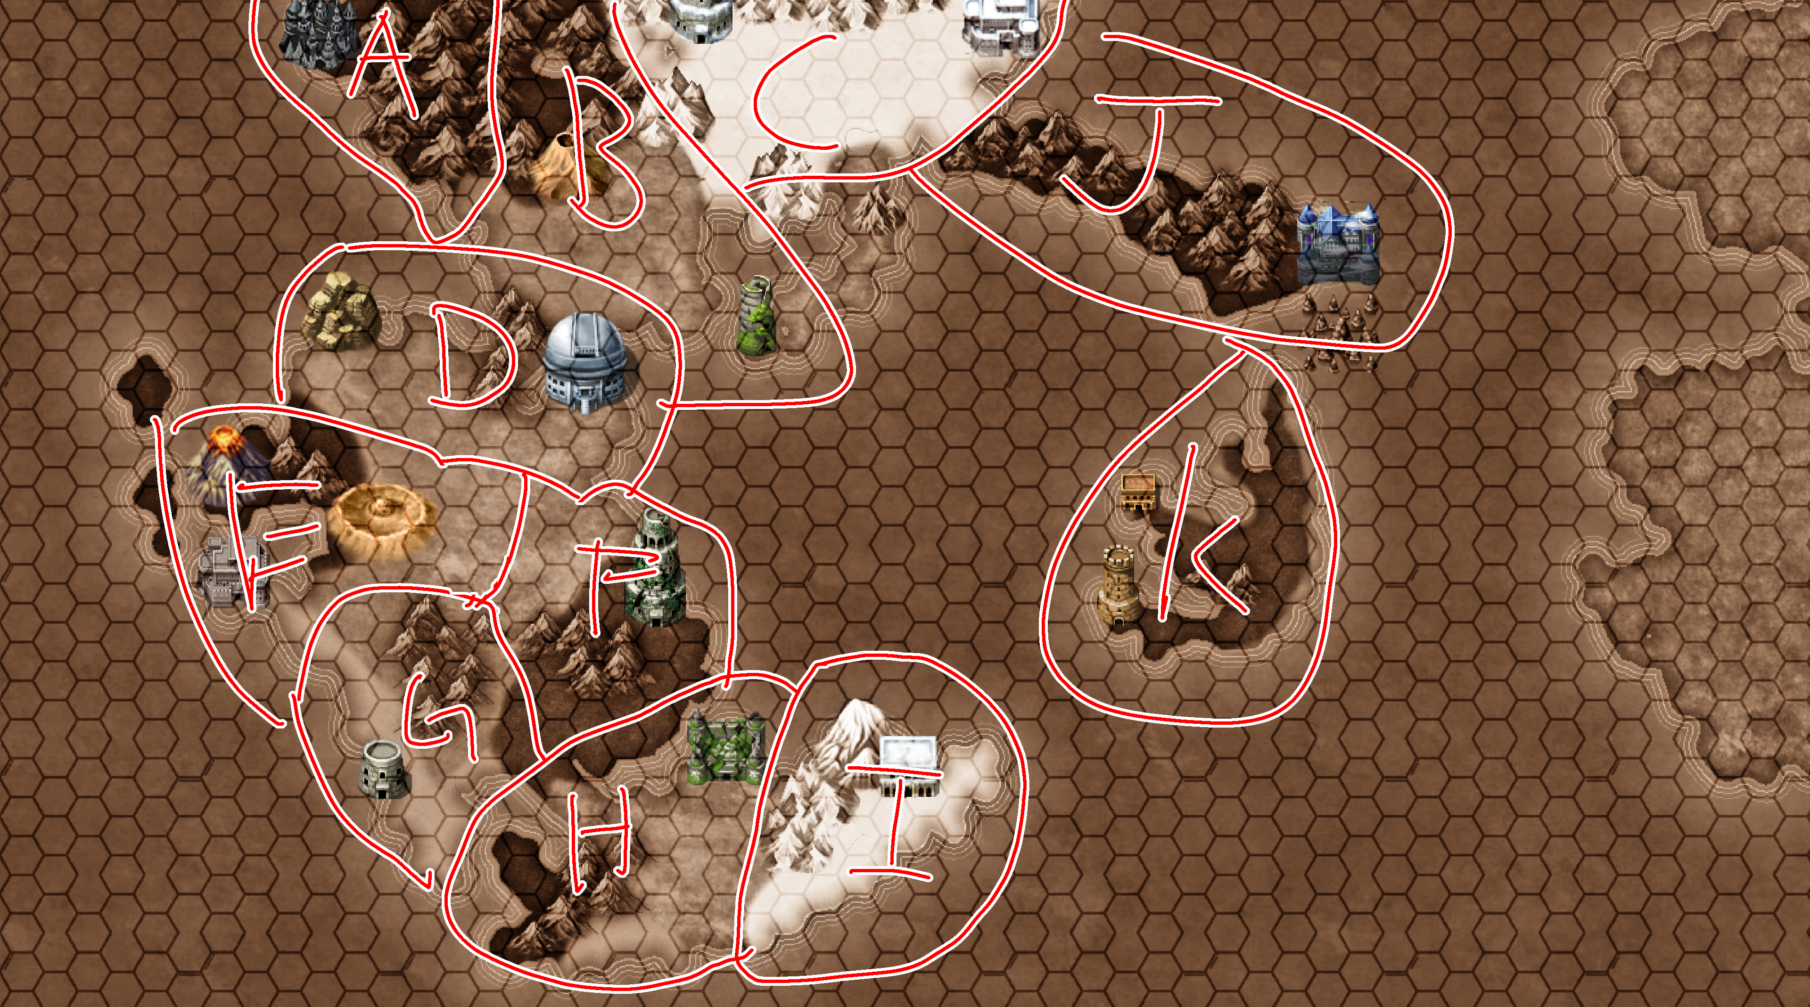
Why zones
Starting Point
Event
Event trigger
Story Events
Qualifiers 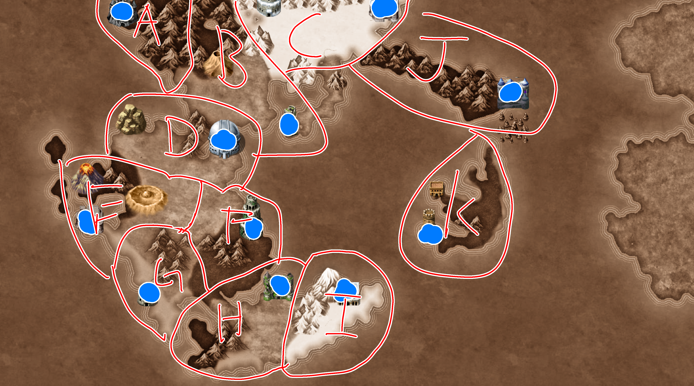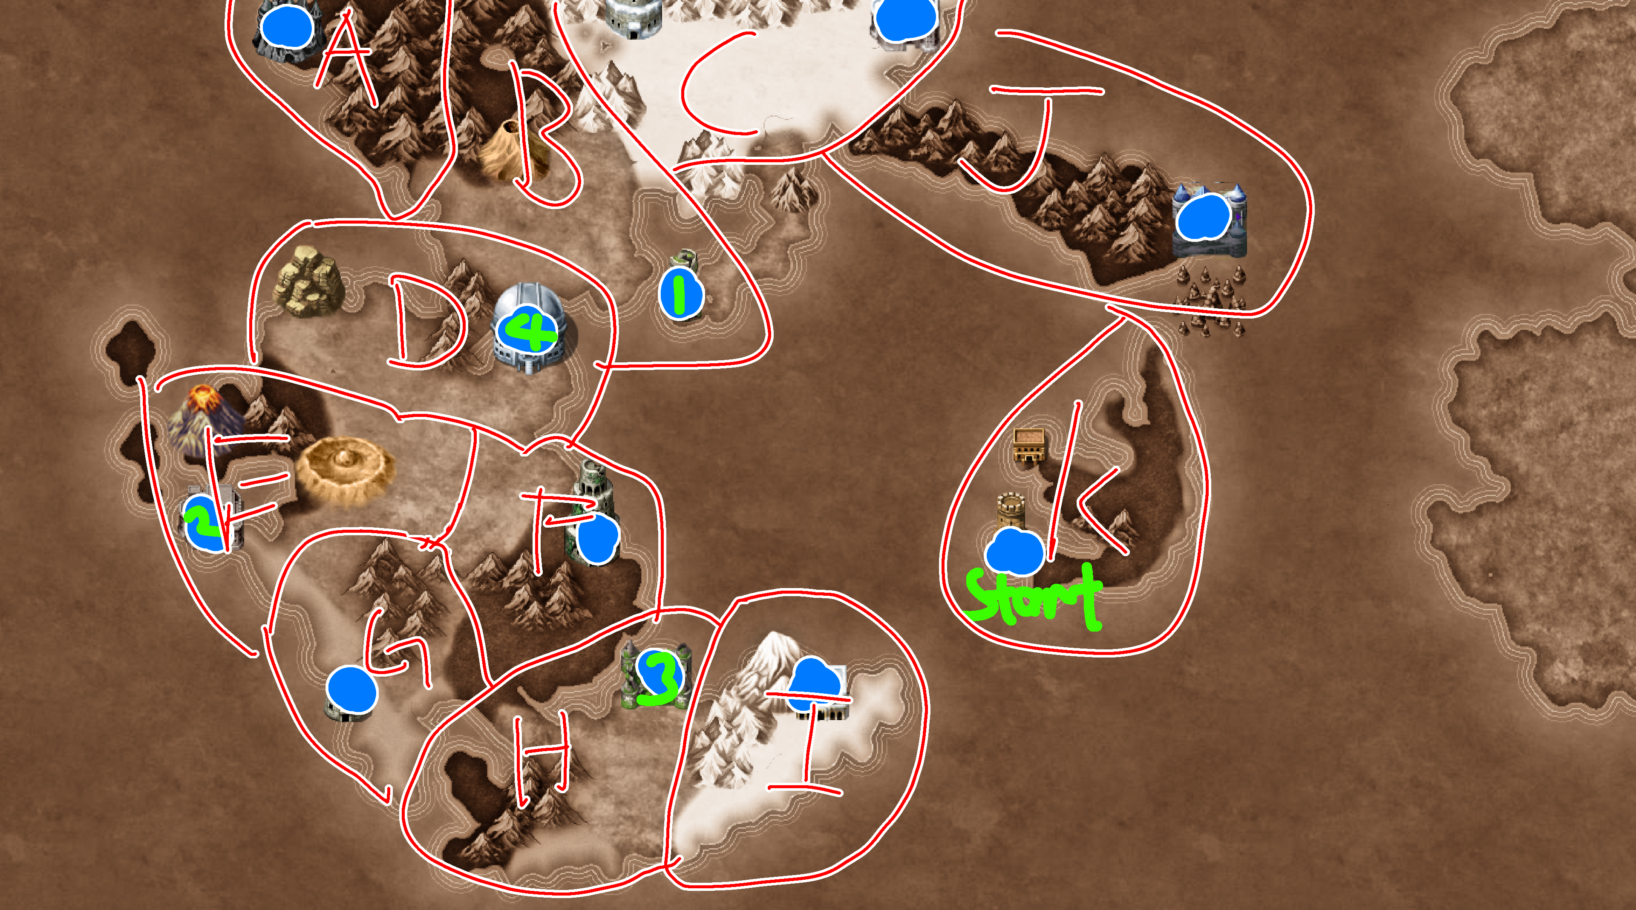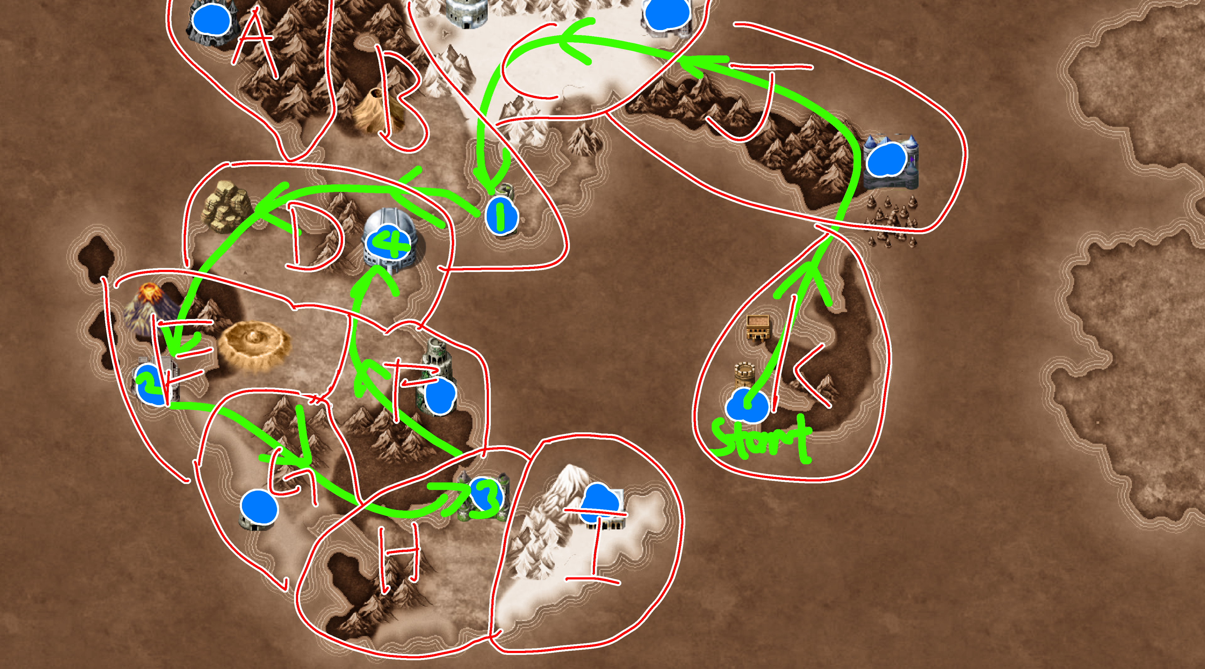
Rival Fights
Training
Leisure Events
Recovery centre
Technique Acquisition
Scheduling

Progression
- -Start the run
- -Choose one starting location (starting locations depending on the dino, eg. One of the zone she can start is volcano zone)
- -Player schedule qualifiers for the dino (always accessible to the player, but the time they can only schedule specific qualifiers is limited)
- Player guide dino in the map to reach their scheduled fight
- Along the way trigger events
  - -Training (up stats) (option in a uma musume screen)
  - -Leisure events (up affinity and trigger side story events) (option in a uma musume screen)
  - -Heal Hp (option in a uma musume screen)
  - Increase Max Hp (Events? Leisure?)
  - -Technique Gain (specific events)
  - -Main story events (story of the career)
  - -Rival fights (Contribute to the main story, up affinity and gain special technique)

- -Reach the gym and battle (Contribute to the main story, up affinity and gain special technique) (also clear one of the qualifiers requirement)
- -Repeat until its time for the big top 16

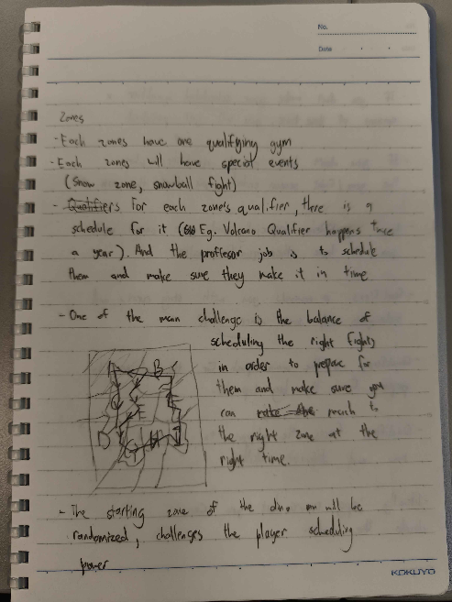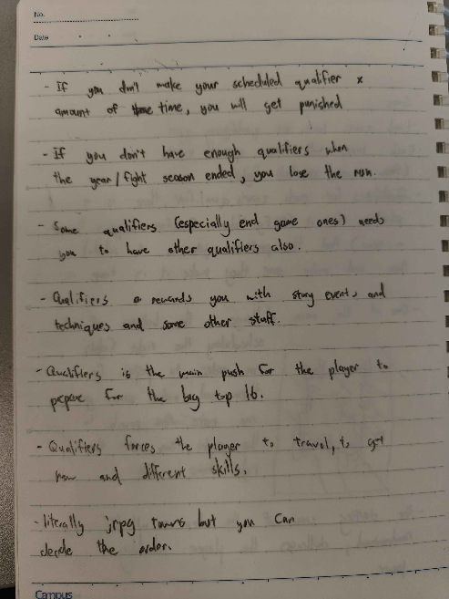

Zones
- Each zones have are qualifying gyms
- Each zones will have special events (Snow zone, snowball fight)
- Qualifiers for each zone's qualifier, there is a schedule for it (Eg. Volcano Qualifier happens 3 times a year). And the professor job is to schedule them and make sure they make it in time.
- One of the main challenge is the balance of scheduling the right fights in order to prepare for them and make sure you can enter the result to the right zone at the right time.
- The starting zone of the show will be randomized, challenges the player scheduling power.

- If you don't make your scheduled qualifier X amount of time, you will get punished.
- If you don't have enough qualifiers when the year/fight season ended, you lose the run.
- Some qualifiers (especially end game ones) needs you to have other qualifiers also.
- Qualifiers rewards you with story events and techniques and some other stuff.
- Qualifiers is the main path for the player to prepare for the big top 16.
- Qualifiers forces the player to travel, to get new and different skills.
- Literally jrpg towns but you can decide the order.

Buildings???
Space that you can trigger without landing on it

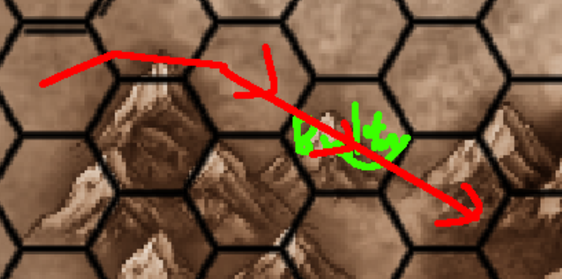
If it pass through that space (maybe use some of your remaining movement), trigger the event without using the rest of your movement.

Prototype asd
9x27 grid
Starting point will be one of the edges
Each zone gets its own unique skill and event card
Whenever you land on another space you draw a card
Goal of each zone is to reach the gym and win the fight
Balancing around rarity (eg. Fight card will have less in the deck, and the dice will have limbus skill amount thing (3 face with one, 2 face with two, 1 face with three))
Use poker cards also. Later the function of each card can be decided later
Gyms will be harder to fight if you fight them early
Schedule gym fights means that you must reach the gym within that amount of turn
Battle use poker cards
You start with a three
If you gain skill = you gain another card from the main deck
Whoever have higher cards win
Shuffle both poker deck and randomly choose a card, whoever higher wins
The opponent cards will be decided by the level(?)(idk how that will work)
Stats is modifier (1 token plus one)
Hp zero cannot battle until healed
Risk award of taking fight you want to spend to hp to fight if not you cannot do much but roam
Scheduling Title Match
-a title match will be open for registration every 3 turns, location random based on D6 roll (1-2=region A, 3-4=region B, 5-6=region C)
-If the player chose to attend that title match, they will sign in
-After three turns, if they didn’t opt out of the title match in those previous 3 turns, they are forced to pay 3 ingredients and they are officially signed in for that title match.
-Within this period, the dino they will be fighting will be revealed and their decks will be mostly revealed. The deck shown vs the deck that you will fight are different. In the actual battle they will have an extra 3 cards in their deck.
-The title match will happen in the next 3 turns, they must in vicinity of the arena (the space adjacent to the arena including diagonals) in order to fight the title match
-If they don’t reach the 3x3 space in time, the are DQ-ed from the title match, they cannot regain the spent ingredient
-Scouting
-Start with 10 ingredients
-Roll d6 = the amount of space you can travel (roll 1-3 travel can 1 space; roll 4-5 can travel 2 space; roll 6 can travel 3 space)
-can choose amount of space to travel, each space traveled cost one ingredient
-once landed roll dice again to see the amount regained (roll amount= ingredient gained)
Landed
-Player either train or cook
-if player choose to train, roll d6, based on the value rolled get the designated suite
[1-2 get diamond
3-4 get non region suite
5-6 get region suite]
-Draw the suite deck based on the suite rolled, before drawing the deck, the player call the value of the card they will draw. Do P-magic damage equal to the difference of called and drew card. If the player correctly called the card, gain 10 P-magic instead
-If the dino is currently in the region which shared it’s own affinity, take the dmg that could’ve been done by calling the value wrong, minus 2.
-if the player choose to cook, Spend up to 3 ingredient to heal (ingredient amount*5) amount of P-magic

Battle
-Use poker cards, 2 decks, one for player one for the npcs
-Each fight can last 3 rounds and each round last 3 turns
-At the start of the round, each side choose up to 5 cards from their current deck to use for the round. After the round start.
-When turns starts, each player randomly draws one card from their deck, that will be their Clash Card.
-Each player will draw another card, that will be the damage card.
-If the affinity for the card is the same as the dino, the card gains +3 clash value
-After the draw, each player will compare their Clash Value, the person with the higher Clash Value will win the clash.
-If they win a clash, do ((14- (Clash Card value)) +weakness dmg modifier of opposite dino) amount of P-magic dmg to the opposite dino.
-After the 3 turns, compare each others P-magic value, whoever has the higher P-magic value gains 1 point. FT2, wins the fight.
-Each dino heals 10 P-Magic at the start of each turn

Win and lose cons
-Win by defeating 3 title matches before 24 turns
-You lose if you don’t have 3 wins before 24 turns
-
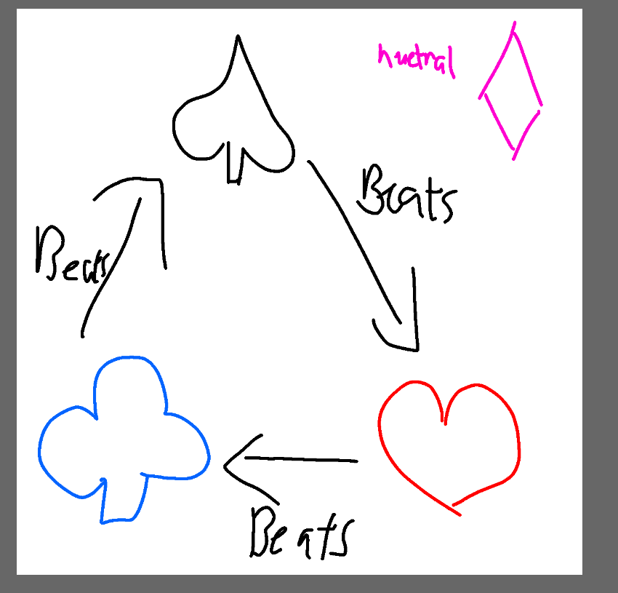

Each dino will have one affinity type. That affinity type will affect their stats during battle. Affinity will determined what attack they are weak against. (e.g trex is a spade dino, so when receiving an attk from a 7 clover card, it will receive (14-7+3)= 10 dmg)

Everything should be tracked by a spread sheet
